Northeastern Oklahoma A&M College
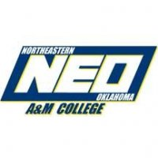
Recommendation/Evaluation Authorization and Waiver

Name of Student (Last, First, Middle Initial): | Student ID: | Date:
The Family Educational Rights and Privacy Act (FERPA) restricts an educational institution from releasing confidential, non-directory information without prior consent of the student. If a letter of recommendation contains non-directory information a written release is necessary. This form waives this restriction for letters of recommendation to be submitted by faculty or staff members.

By completing and signing this form you authorize the identified staff or faculty member to provide information pertaining to your education record as appropriate for your recommendation to the entity identified.
Name of NEO A&M College official making recommendation or evaluation:
Name:
Type of Disclosure (check all that apply):
- Letter of Recommendation
- Evaluation Form
- Verbal Recommendation/Evaluation
- Other (please specify):
Person or agency to whom education records may be provided:
Name:
Purpose of release:
- Employment
- Scholarship
- Admission to an Educational Institution
- Other (please specify):
Waiver of access (check one):
- I waive the right to review the requested recommendation/evaluation.
- I DO NOT waive the right to review the requested recommendation/evaluation.
By signing below, I authorize the NEO A&M College official named above to disclose such educational records as that official considers appropriate based on the purpose of the request. This is a one time release for the purpose listed above.

Student’s Signature Date

This form must complete and signed by the student. Records should not be released if any section is not filled out entirely. The school official named above should maintain the completed form.

